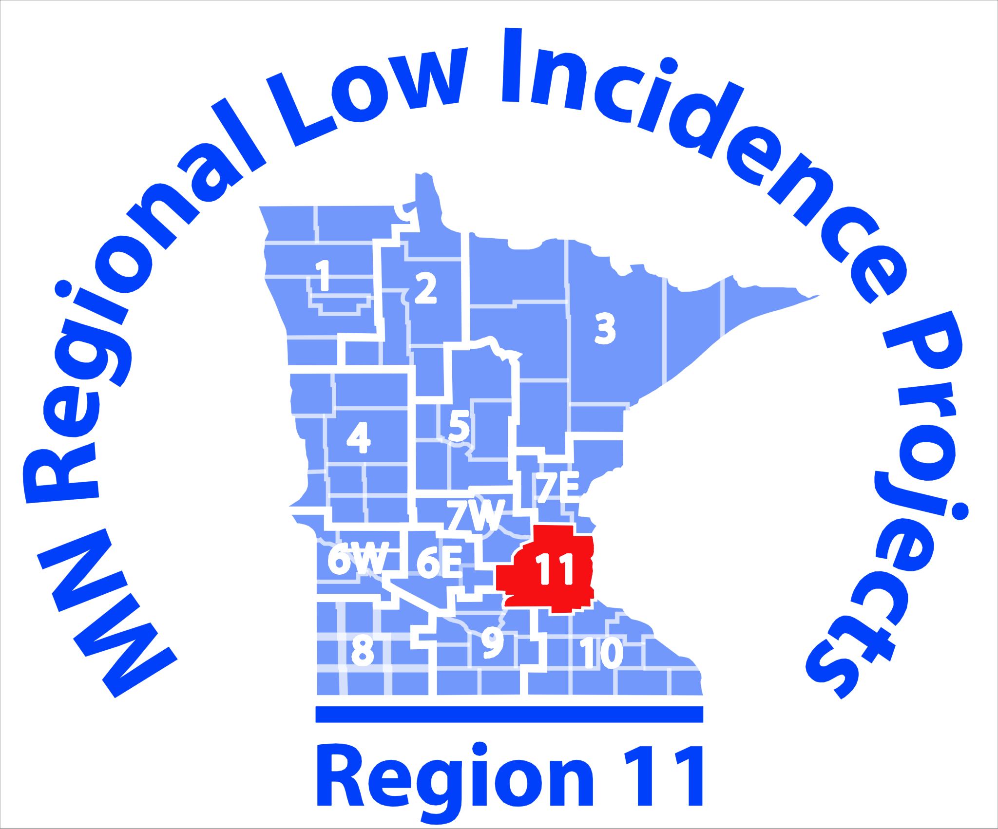
Agenda
8:30 – 9:00 AM
- Updates and News: Co-Coaches Taylor Thomas and Emily Manson
9:00 – 11:30 AM (Break from 10:00-10:20 AM)
- Mental Health Panel
  - Rachel Schultz, Social Worker for students who are D/HH for St. Paul Public Schools
  - Valerie Enfiejian, School Psychologist for ISD 917 working with students who are D/HH
  - Tarra Grammenos, presenting on suicide and bullying
  - Additional Panelist TBD

11:30 – 11:45 AM
- Discussion and Individual Questions with Panelists
11:45 AM – 12:15 PM
- Working Lunch, Updates from MDE and DHH CoP members
12:15 – 12:45 PM
- Refresher on Google Site- How to access, edit, and upload resources.
12:45 – 3:00 PM
- D/HH Toolkit- Develop/Share Resources, hands-on work time.
Note Taker: TBD
Upcoming Meetings in 2018: February 21, May 16

